CS 255 System Design Document
Emmett Perreault

UML Diagrams

UML Use Case Diagram
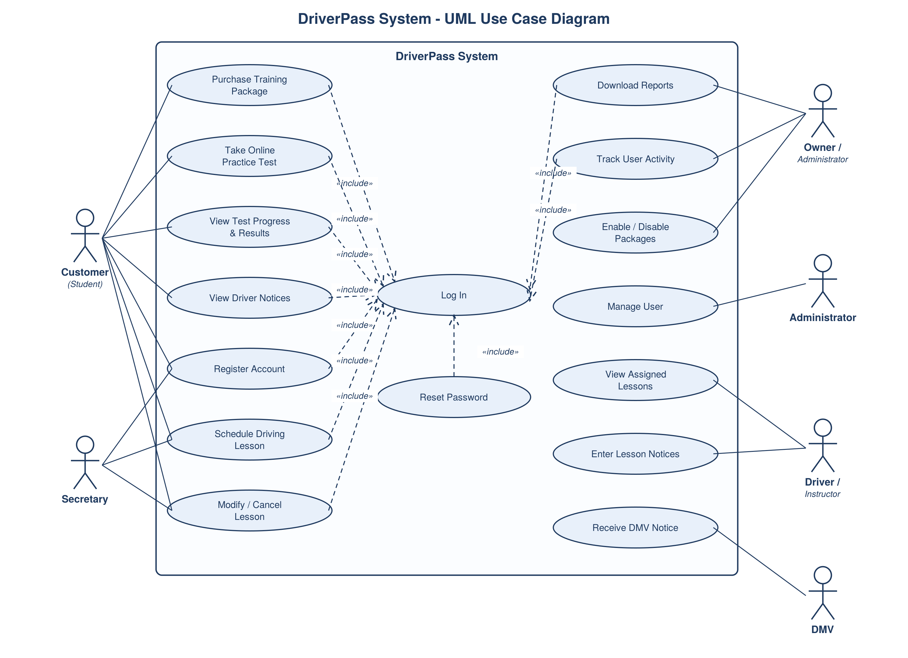

UML Activity Diagrams
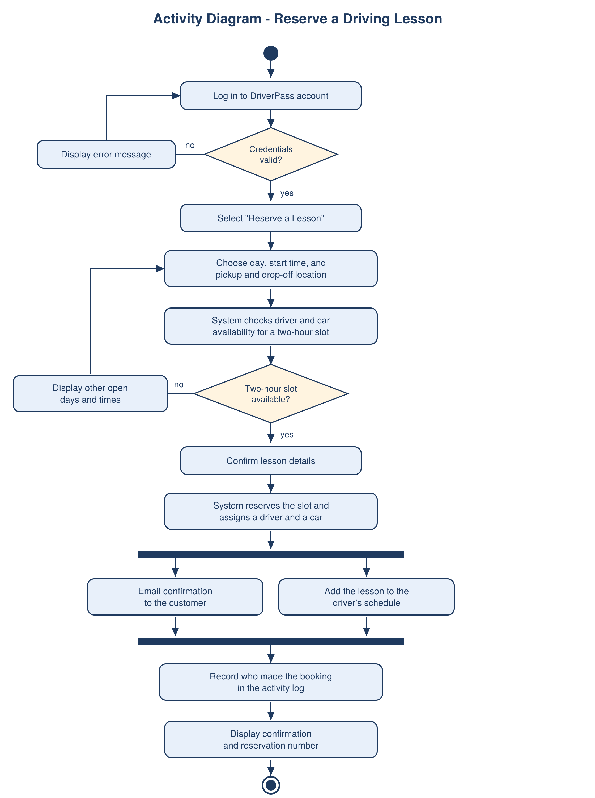
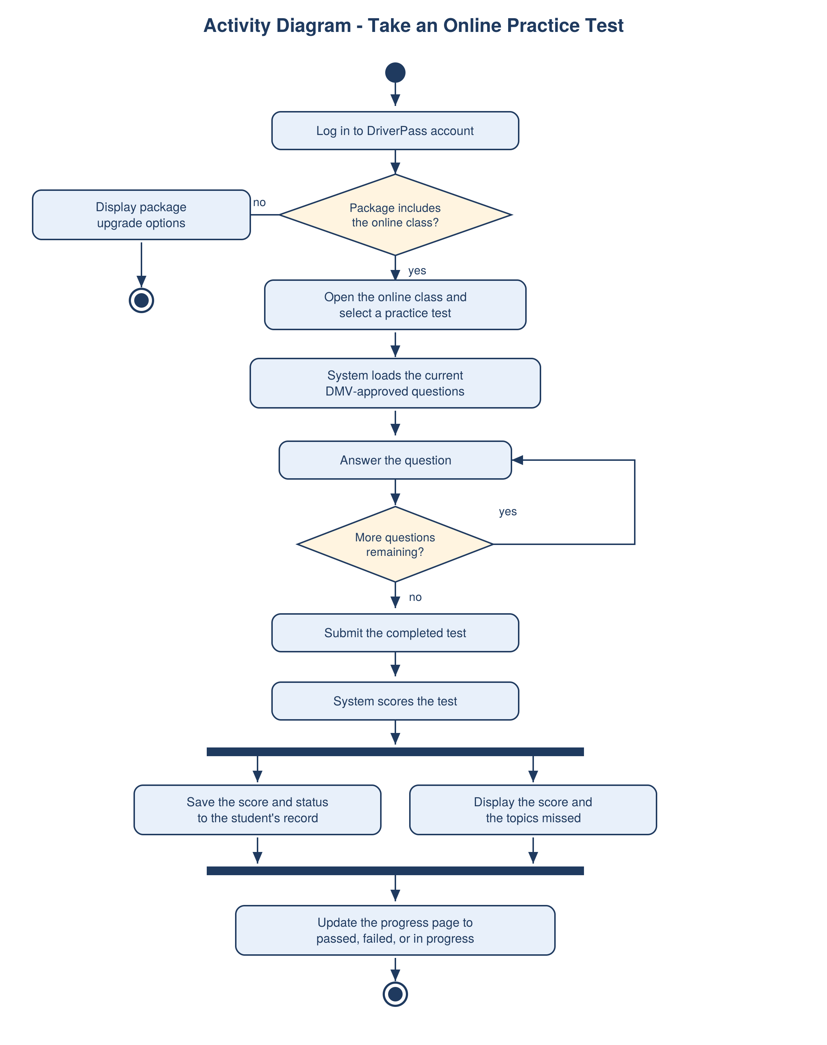

UML Sequence Diagram
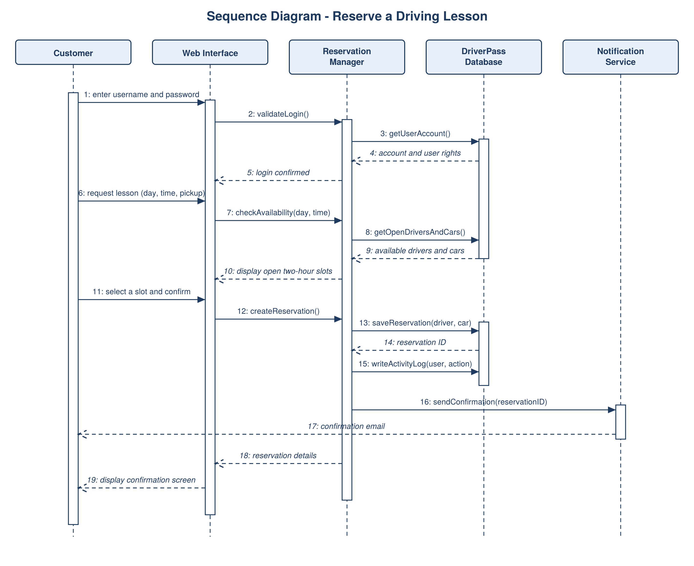

UML Class Diagram
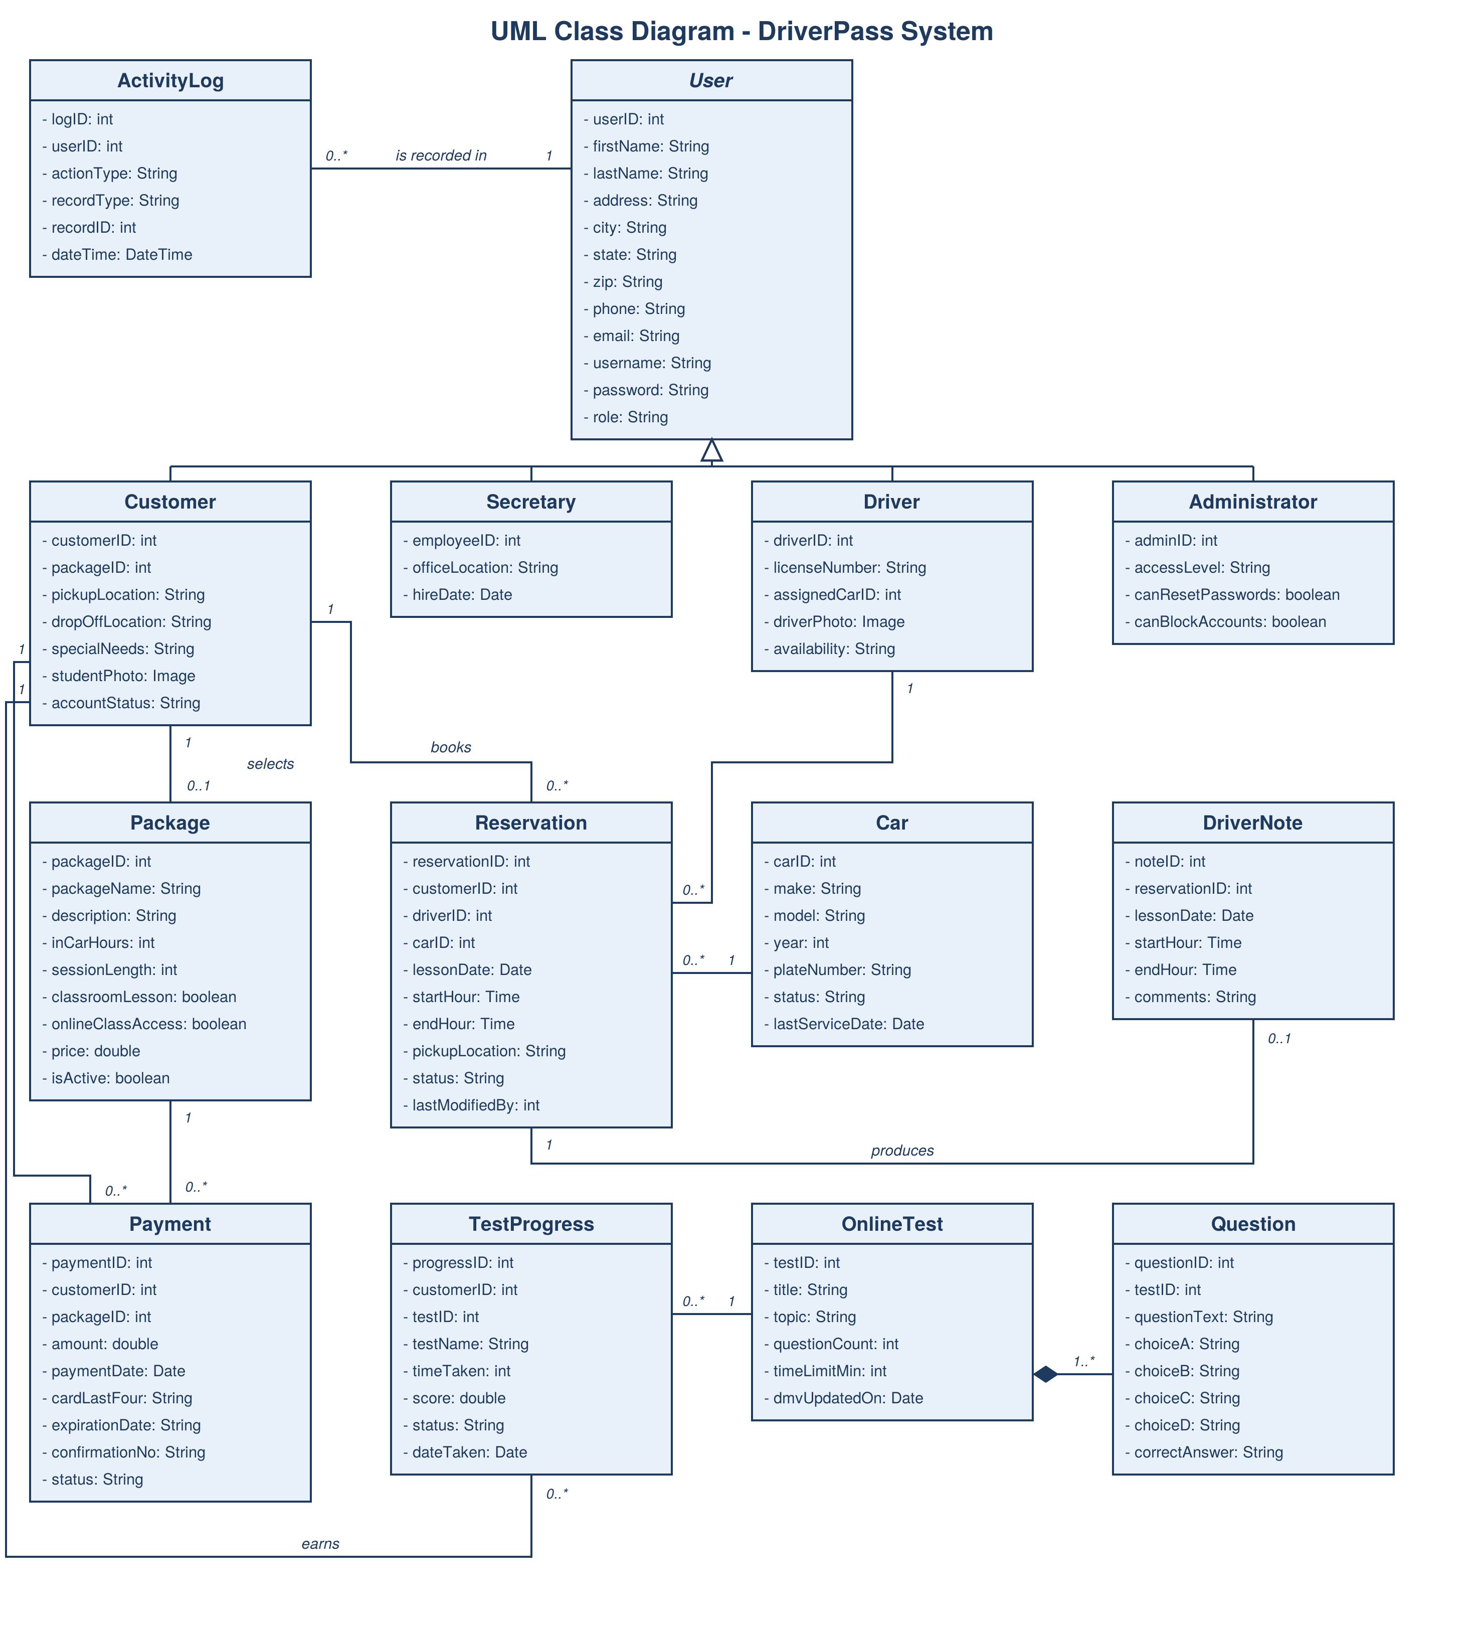

Technical Requirements
The system runs on rented cloud servers instead of anything DriverPass has to buy, with two servers running the website behind a load balancer and one running the database with a backup copy, while the office keeps normal computers and the drivers get tablets for writing their notes after a lesson. The software is Linux with encryption turned on, the business rules in Java using Spring Boot, a database like PostgreSQL or MySQL, and one website built in HTML, CSS, and JavaScript that works on a phone, a tablet, or a computer, plus outside services for the card payments, the email confirmations, the DMV updates, and the reports Liam downloads into Excel. The team builds it with Lucidchart for the diagrams, IntelliJ or Visual Studio Code with a shared GitHub repository, Jira or Trello for the task list, and JUnit, Selenium, Postman, and Docker for testing and releases. Hosting all of it with a provider like AWS or Azure across more than one data center covers the backups, the security, and the uptime Ian asked us to take off his plate, and access still stays set by role with every change written down so Liam can print the activity report.

